

**2024**

|  |  |  |
| --- | --- | --- |
| Supervisor | Miss Aqsa Khan | |
| Batch | **PR2-202303C+2212C** | |
| Group | **A** | |
| Serial No. | **Enrollment Number** | **Student’s Name** |
| 1. | Student1442430 | Sarfaraz |
| 2. | Student1455790 | Sajjad Ahmad |
| 3. | Student1462386 | Shahid |
| 4. | Student1459111 | Junaid Khan |

# **Table of Content**

­­

* **Table of Contents**.……………………………….…….……………..**.01**
* **Certificate of Completion**……….………………………….….……....**02**
* **Acknowledgement**………………………………………….……...….**03**
* **Problem Statement**….………………………………...……....…..…..**04**
* **Functional Specification**.……………………………………...…….…**05**
* **Hardware and Software Requirement**…………..……….…….….……..**06**

* **Project Synopsis**…………..…………………………..…….….……..**07**
* **Website Features** …………..…………………………..…….…..…...**07**
* **Database Design**………….....……………………….......…….…..…..**08**
* **Admin Panel**………….....……………………....………….….…..…..**09-17**
* **Home Page**………….....……………………....…………….…..…..**18-21**
* **About Us………………………..** ....……………………....……….…..…..**22**
* **Service………………….** ..……………………....……….…..……………**23**
* **Pages…………………………..** …………......……..……….….…..….**24-25**
* **Contact…………………………..** …………......……..……….….…..….**26**
* **Header………………………….. …………......……..……….….28**
* **Footer………………………………………………………………...29**
* **Admin Login……………………………………………………….30**
* **Admin Logout…………………………………………………………31**
* **Hospital Login………………………………………………………32**
* **Hospital Logout………………………………………………………33**
* **Parents Login………………………………………………………34**
* **Parents Logout………………………………………………………34**
* **Appointment…………………………………………………………35**

# **Certificate of Completion**

This is to certify that  **Sarfaraz, Sajjad Ahmad, Shahid, Junaid Khan** have successfully completed their ACCP Prime 2.0

Semester II E-Project.

Submitted to: **Aptech Computer Education**

On

**Feb 26th, 2024**

# **Acknowledgement**

First of all we would like to thank **Almighty Allah** for giving us strength and ability to complete this project.

And then, we would like to express my special thanks of gratitude to our teacher **Miss Aqsa Khan** who guided us on the project **Vaccination Management System,**

which also helped us in doing a lot of new learning and we came to know about so many new things we are really thankful to her.

We are highly thankful to **Miss Aqsa Khan** for her guidance and constant supervision as well as for her support in completing the project.

Lastly, we extend our heartfelt gratitude to the following individuals and organizations who contributed to the success of this project:

Parents and Guardians: For their active participation, feedback, and trust in the system.

Healthcare Professionals: Their expertise guided the design and implementation.

Software Developers and Designers: Who worked tirelessly to bring this vision to life.

Government Health Departments: For their support and collaboration.

# 

# **Problems Statement**

 In the existing system, Vaccines are provided for infants and children under teenage by various aspects such as by attending school manually and there is a chance that some of the children’s and infants may miss the opportunity of getting vaccinated due to some mandatory reasons. Which leads to loss of life or gets affected by various diseases such as polio… etc? This is a time delay process to wait for each and every one all over the places.

# **Functional Specification**

# **The Website is to be created based on the following requirements.**

## Admin

* All child details
  + View all child profile details
* Date of vaccination
  + Upcoming Date of vaccination of all child
* Report of vaccination
  + Child, Vaccination (Date wise report)
* List of vaccine
  + available or unavailable
  + Admin can view the availability of the vaccination
* Request from parents
  + Approve or Reject
  + Once the request for appointment from parent side, it will be approved from the admin
* Add Hospital
  + Admin can add the hospital details
* Update/Delete Hospital
  + Admin can update or delete the hospital details
* List of hospitals
  + Admin can view the hospital details
* Booking Details
  + Admin can view the booking details from parent side for booking vaccination

## Parent

* Details of child
  + Update and maintain the child details of vaccination
* Vaccination Dates
  + Can get notified through in Dashboard of their respective accounts about upcoming vaccinations.
* Book Hospital
  + Use can search the list of hospital and book schedule for the vaccine dates
* Report of vaccination taken
  + Can get the report status of previous vaccination of their respective Infants

## Hospital

* Register & Login
  + Can register and login into the app with hospital name, address and location details.
* Update Vaccine status
  + Hospital will receive the appointment once its booked from admin side. If vaccination is completed they will update the status to Vaccinated or not.

# 

# **Hardware and Software Requirements**

**Hardware**

* A minimum computer system that will help you access all the tools in the courses is a Pentium 166 or better
* 128 Megabytes of RAM or better

**Operating System**

* LINUX / Windows 2000 Server (or higher if possible)

**Software**

* PHP
* MySQL
* PERL
* Apache

**Project Synopsis**

We can change this manual system into e-vaccination system by collecting the info of infants, registered under website so that those who didn’t took vaccination can avail one more opportunity to save the life of their children. By this system a lot of man-hours can be saved and it is efficient too.

# **Website Features**

The internet is an important source of vaccine information for parents. We evaluated and compared the interactive content on an expert moderated vaccine social media (VSM) website developed for parents of children 24 months of age or younger and enrolled in a health care system to a random sample of interactions extracted from publicly available parenting and vaccine-focused blogs and discussion forums. The study observation period was September 2013 through July 2016. Three hundred sixty-seven eligible websites were located using search terms related to vaccines. Seventy-nine samples of interactions about vaccines on public blogs and discussion boards and 61 interactions from the expert moderated VSM website were coded for tone, vaccine stance, and accuracy of information.

**Database Design**

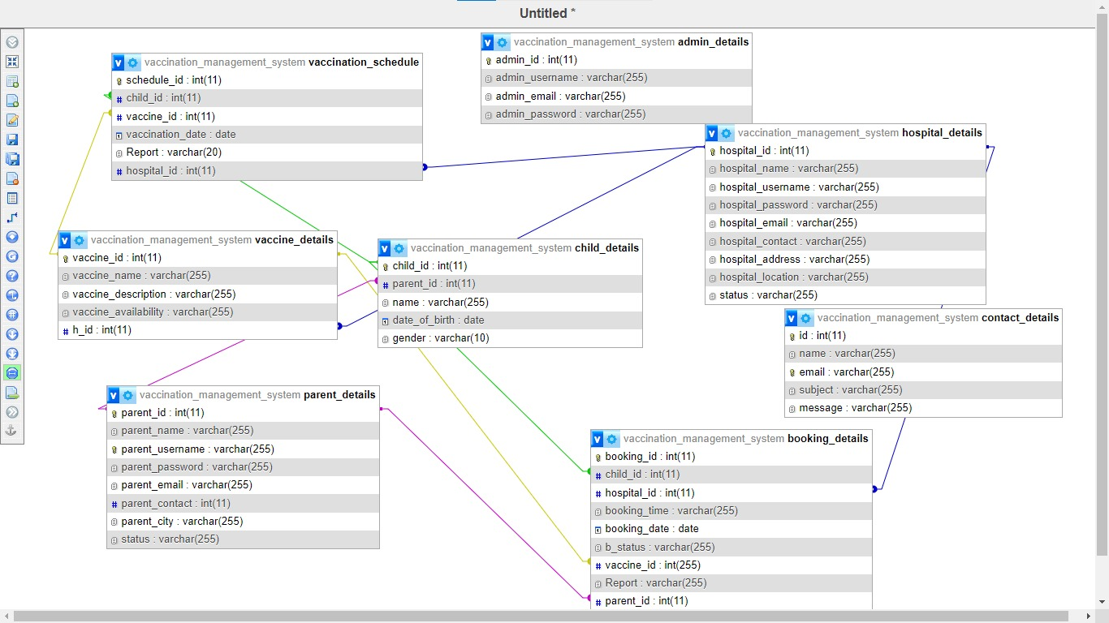

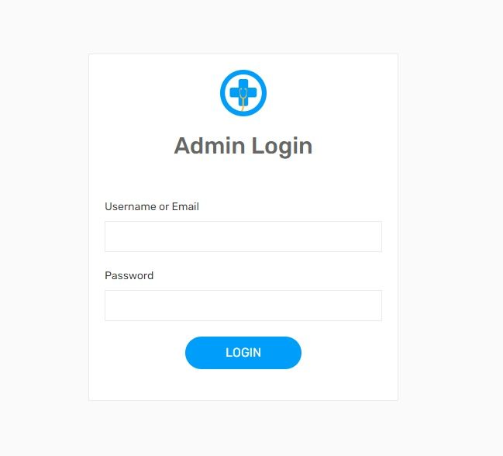Admin Login

Admin Dashboard

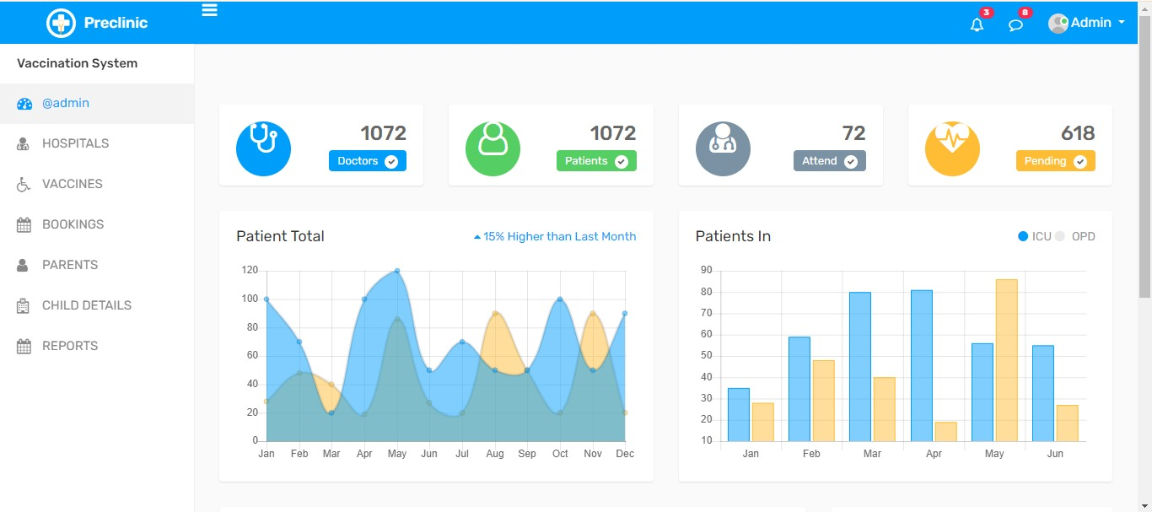

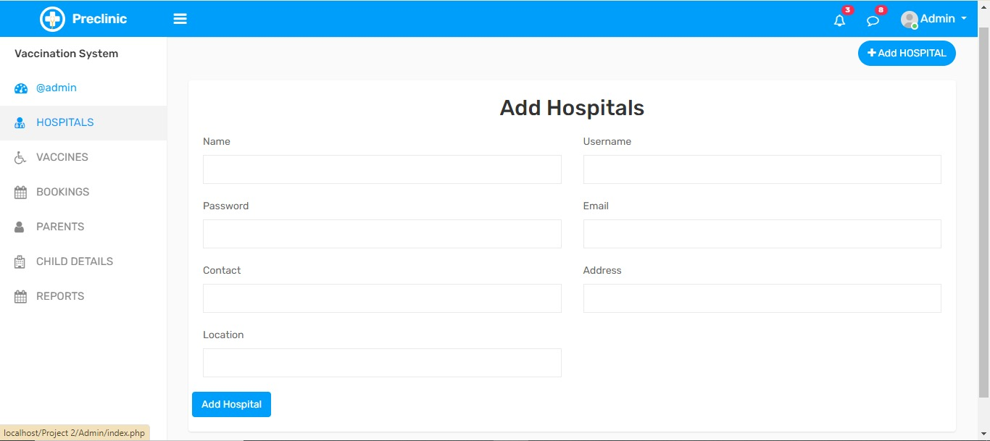

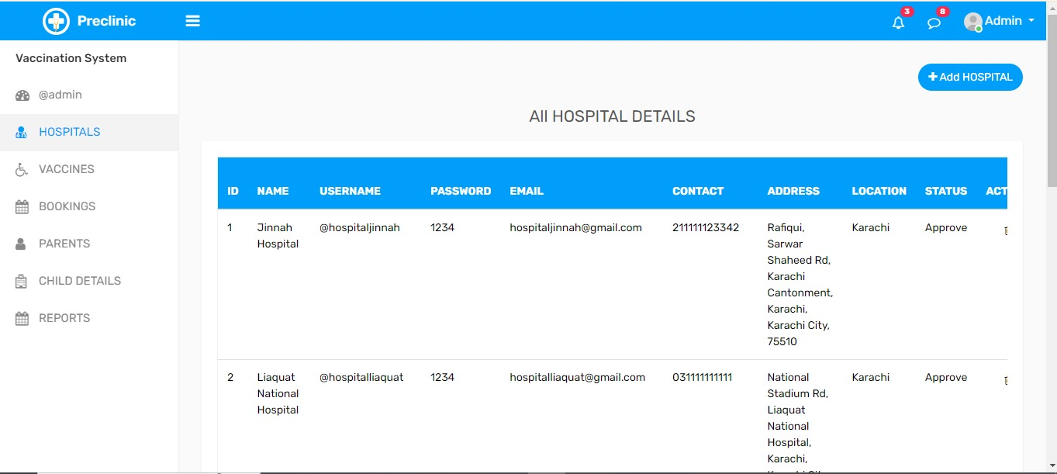

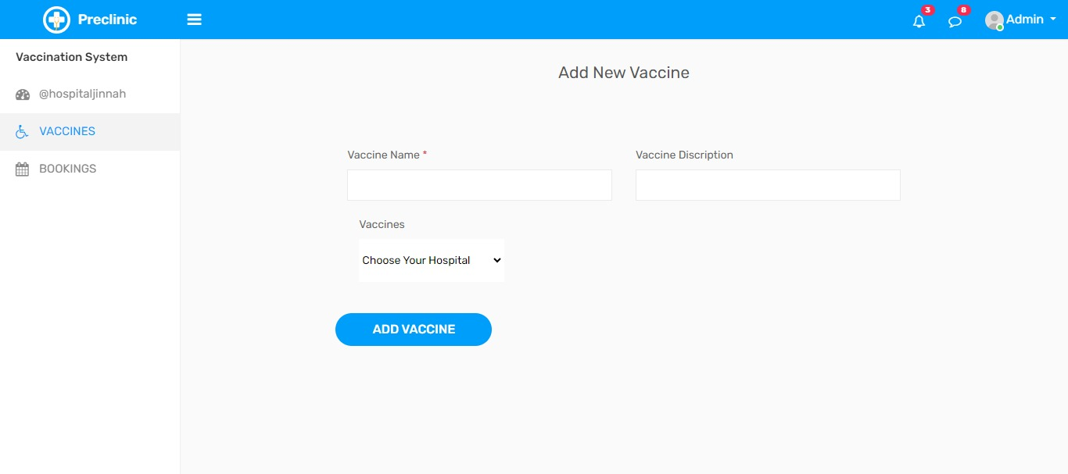

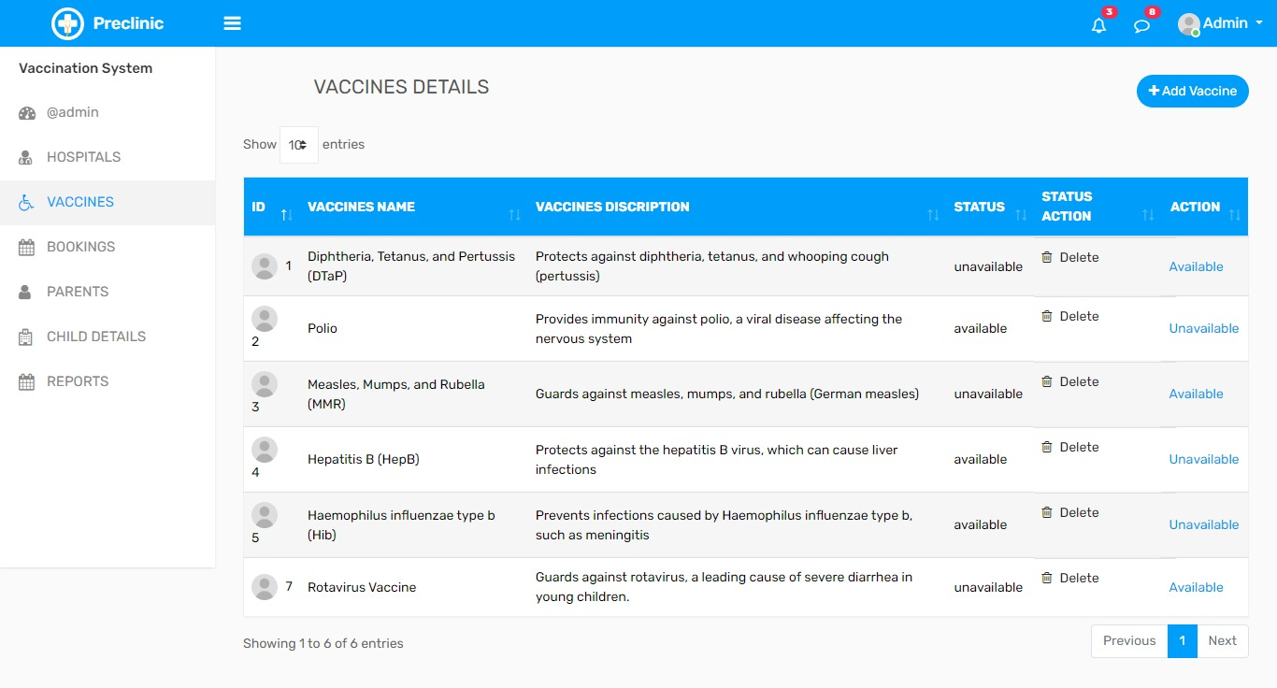

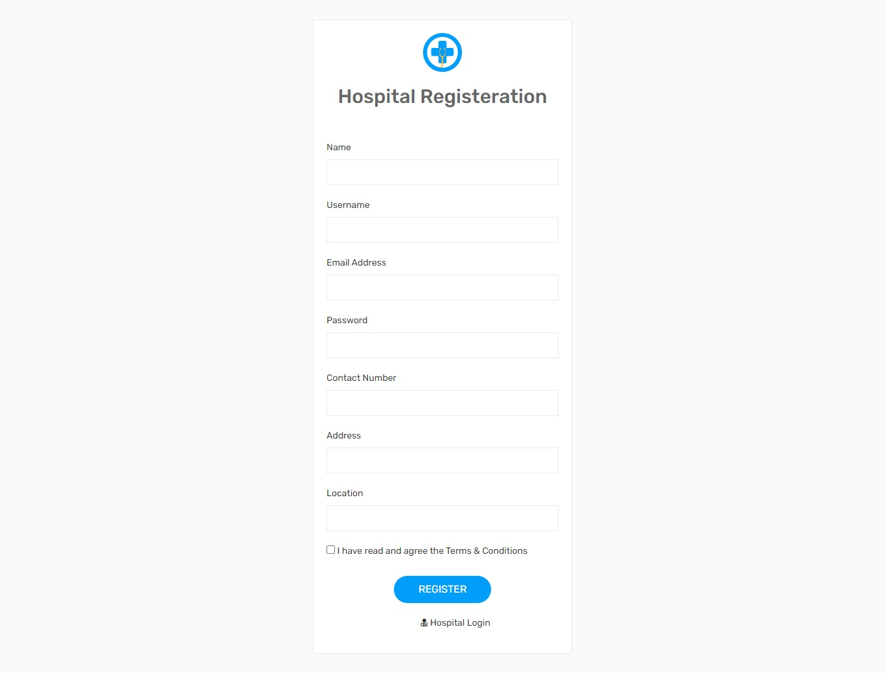

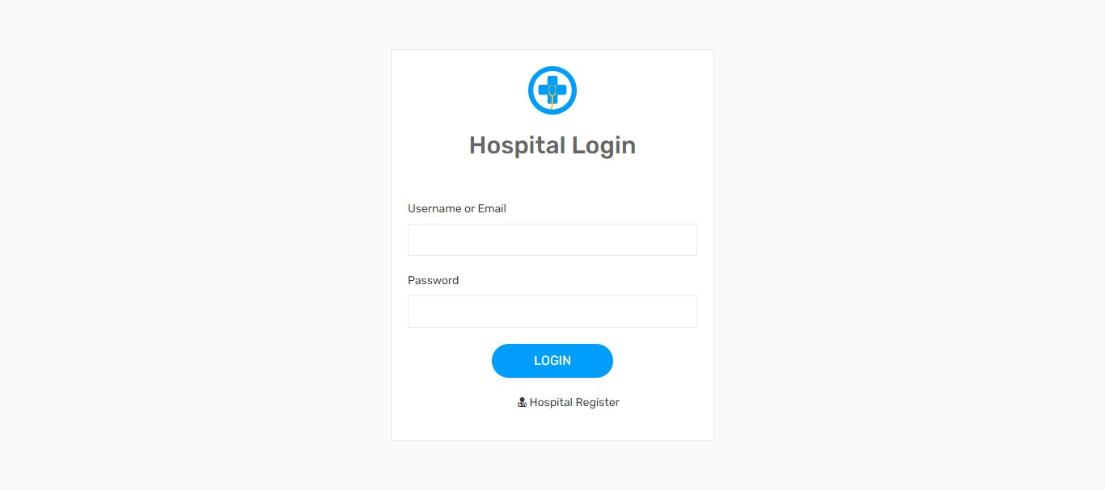

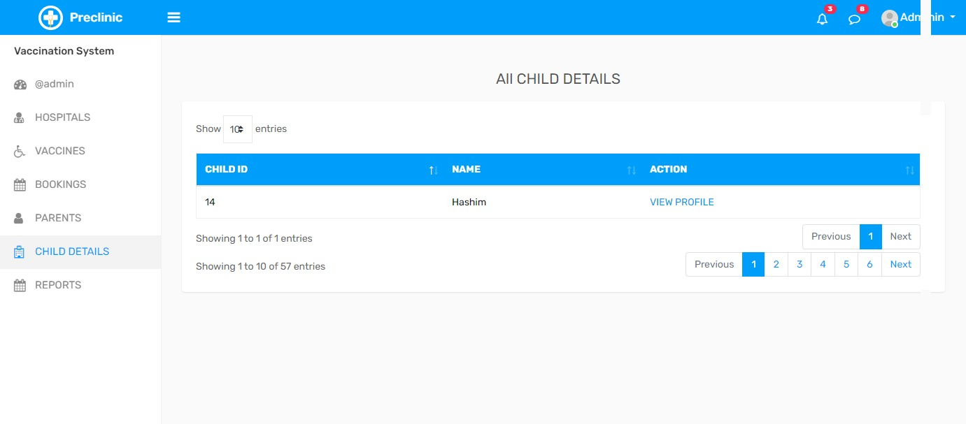

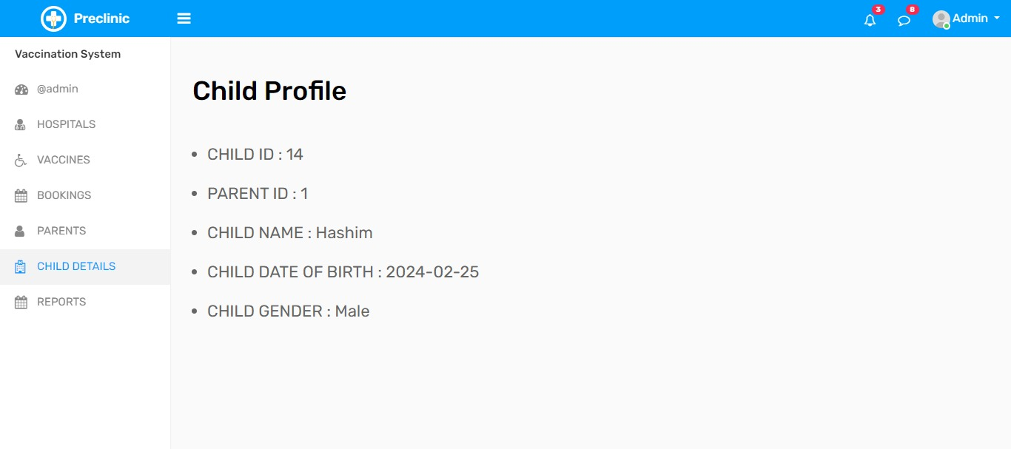

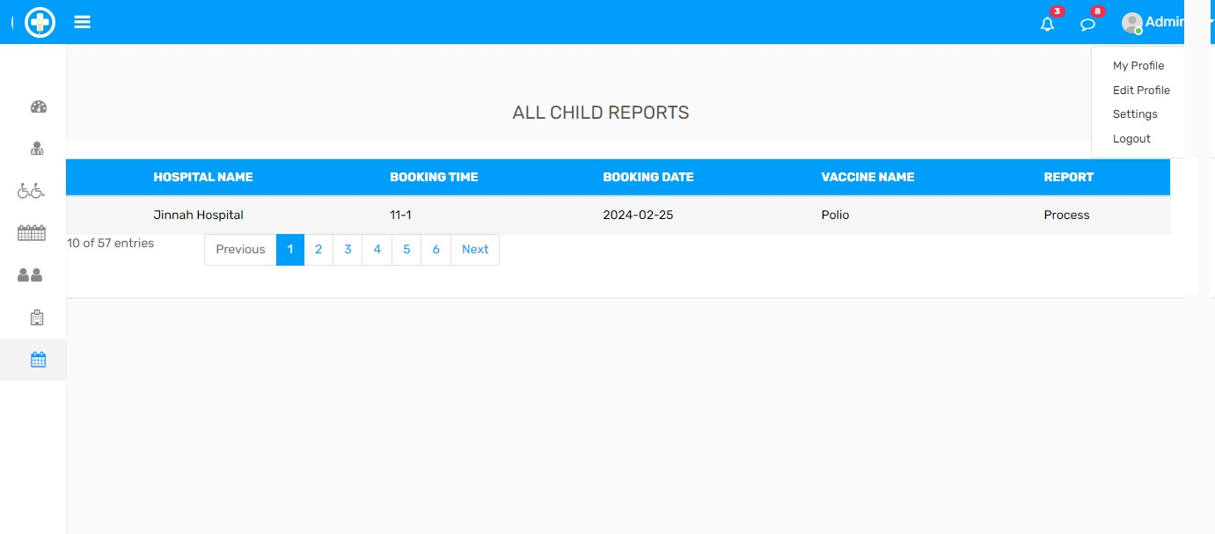

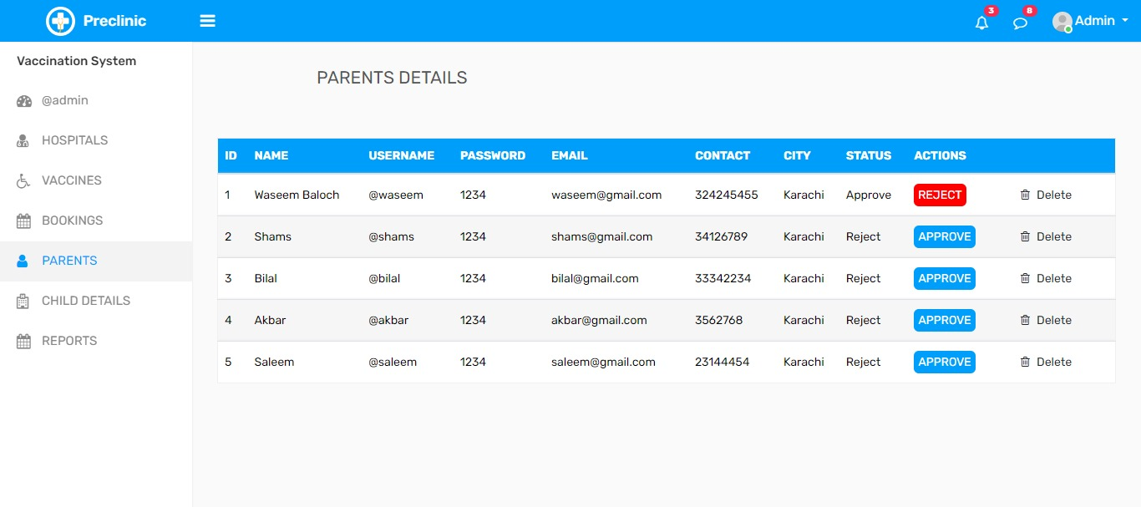

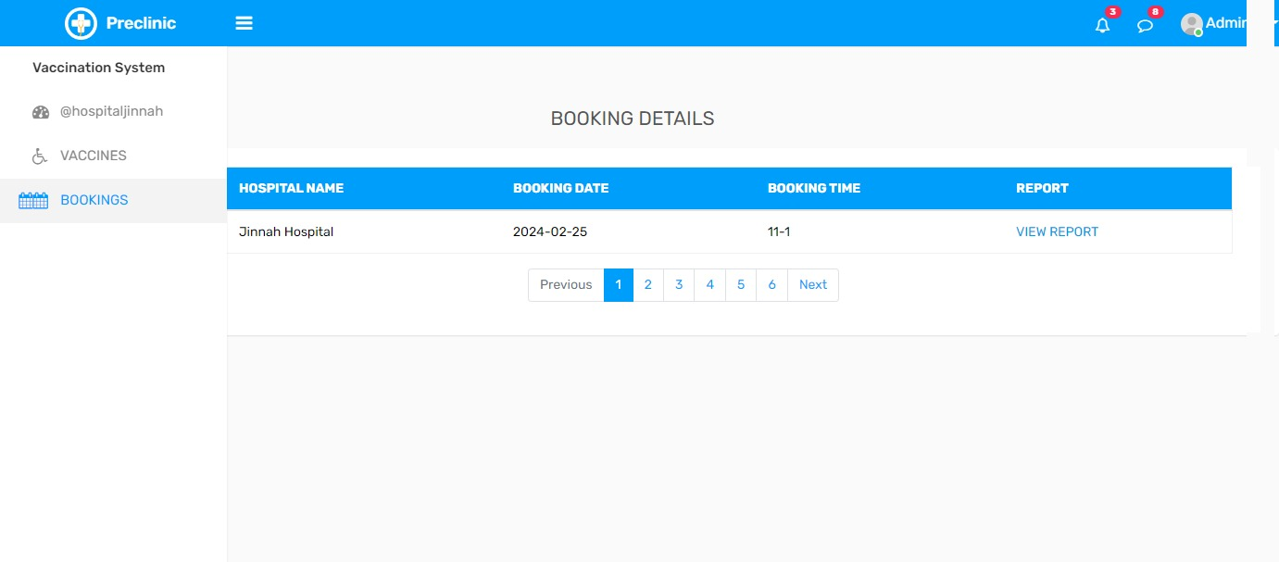

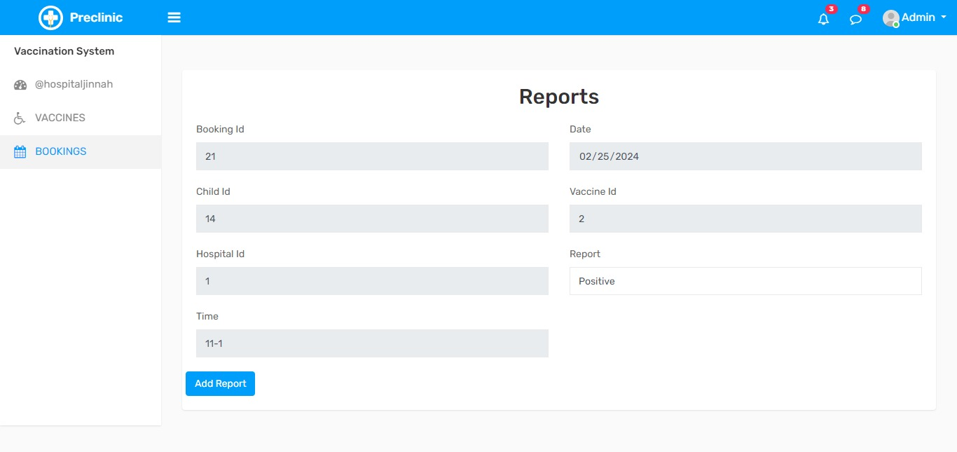

Home Page

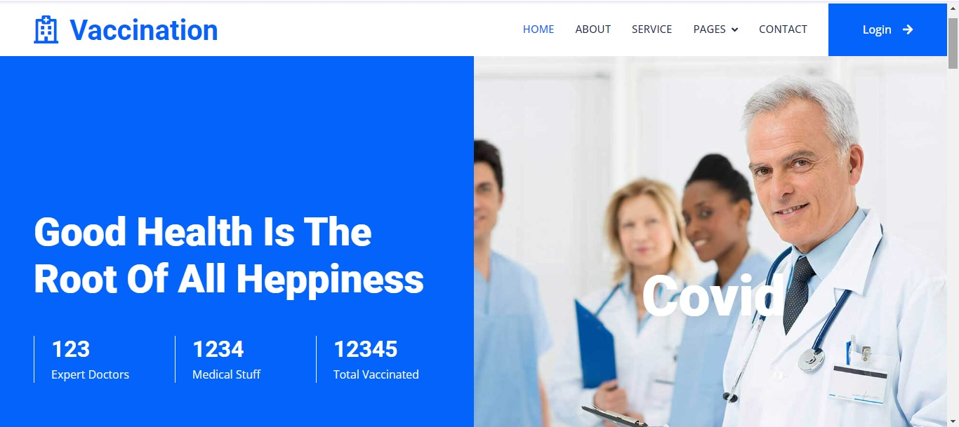

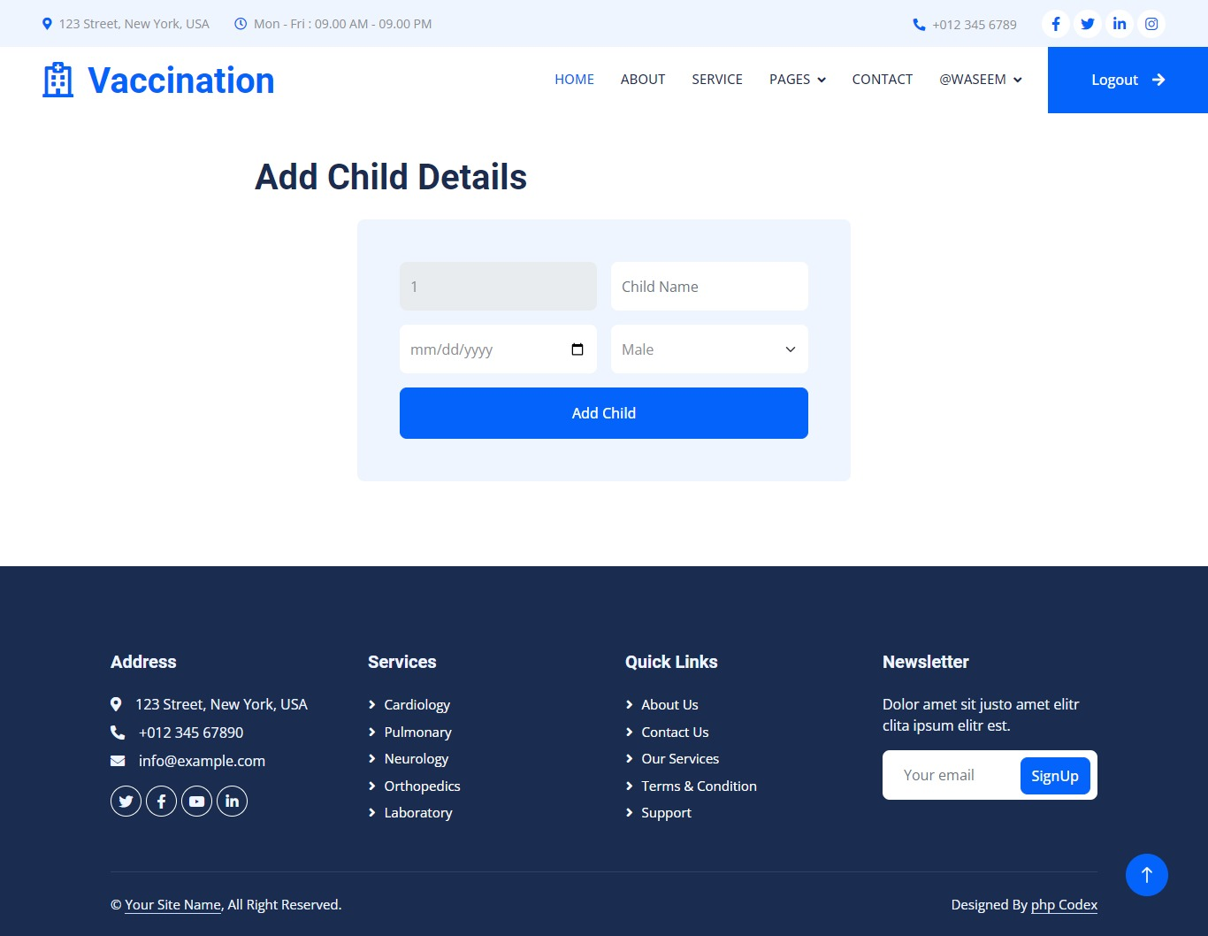

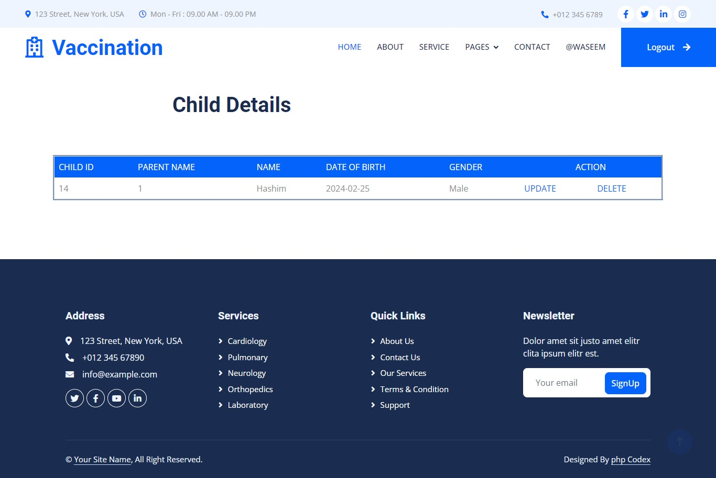

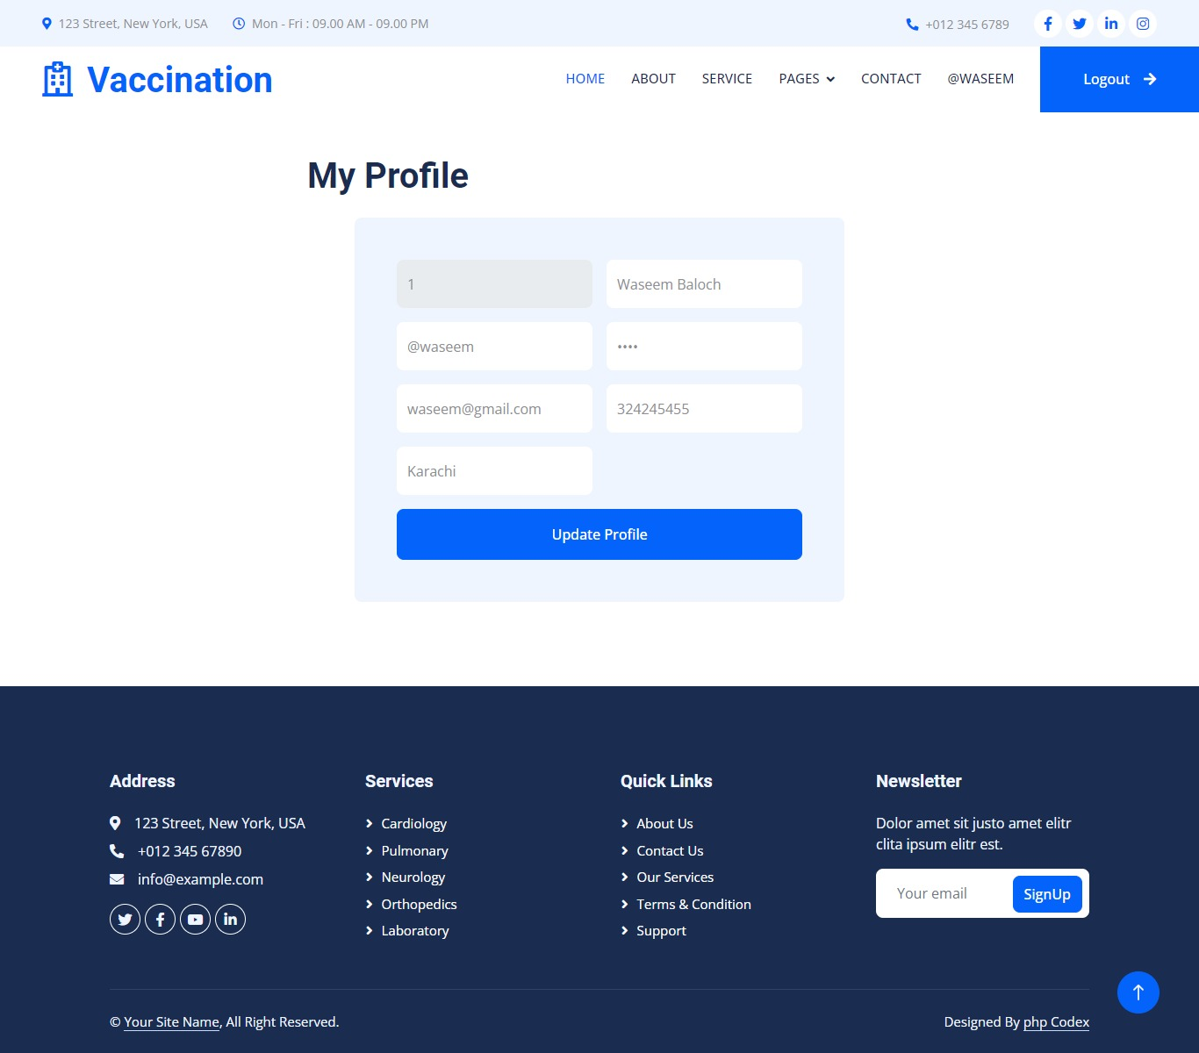

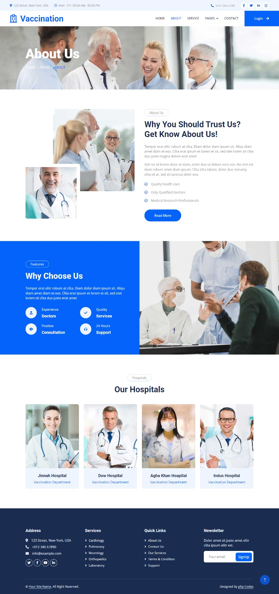About Us

Service

**

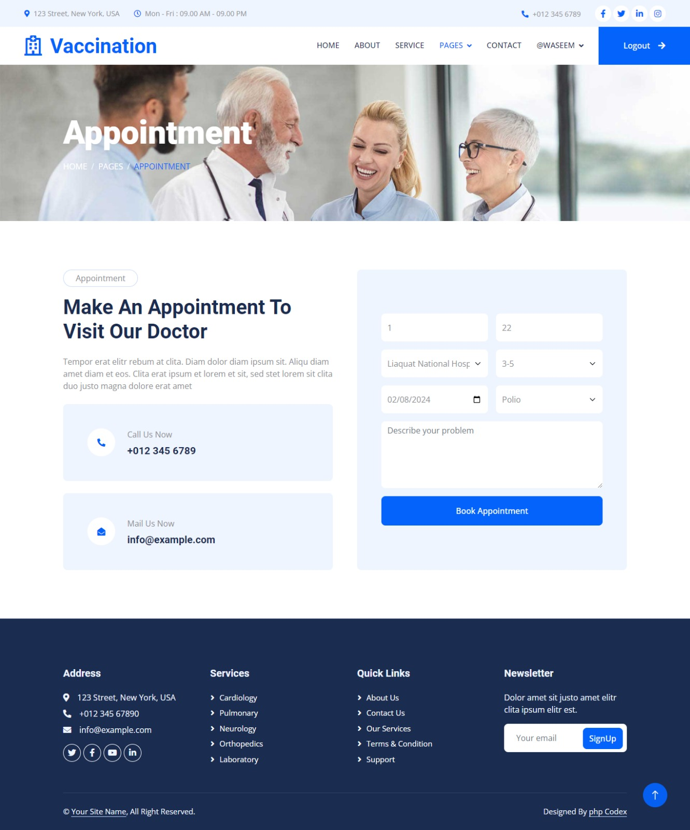Pages

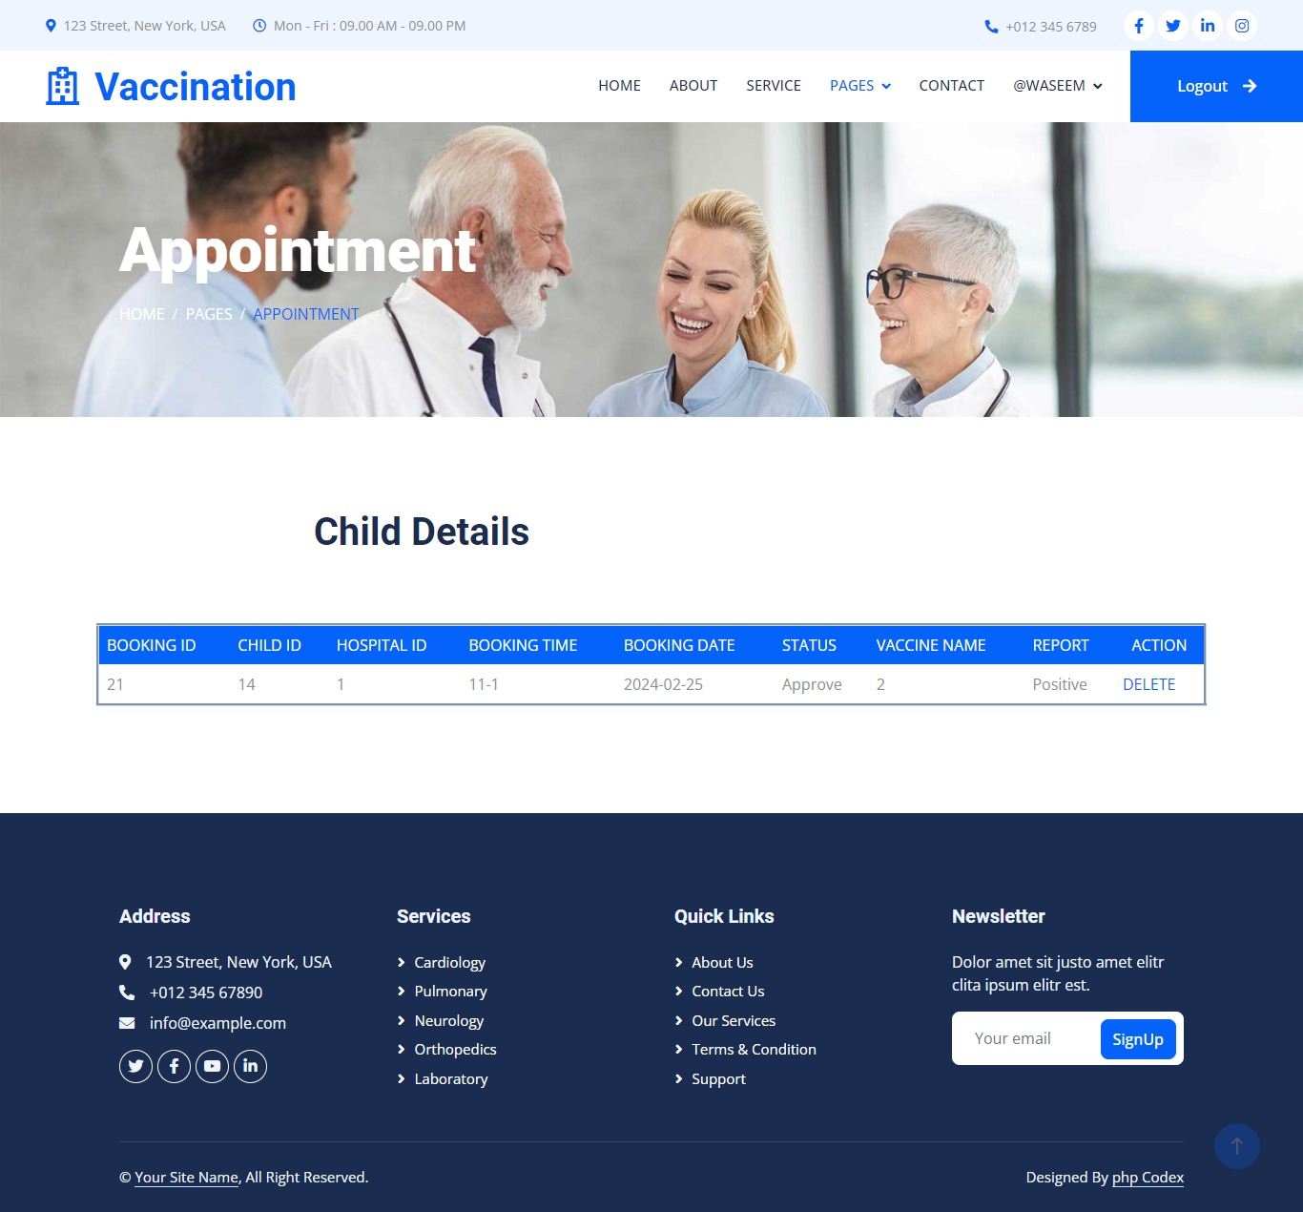

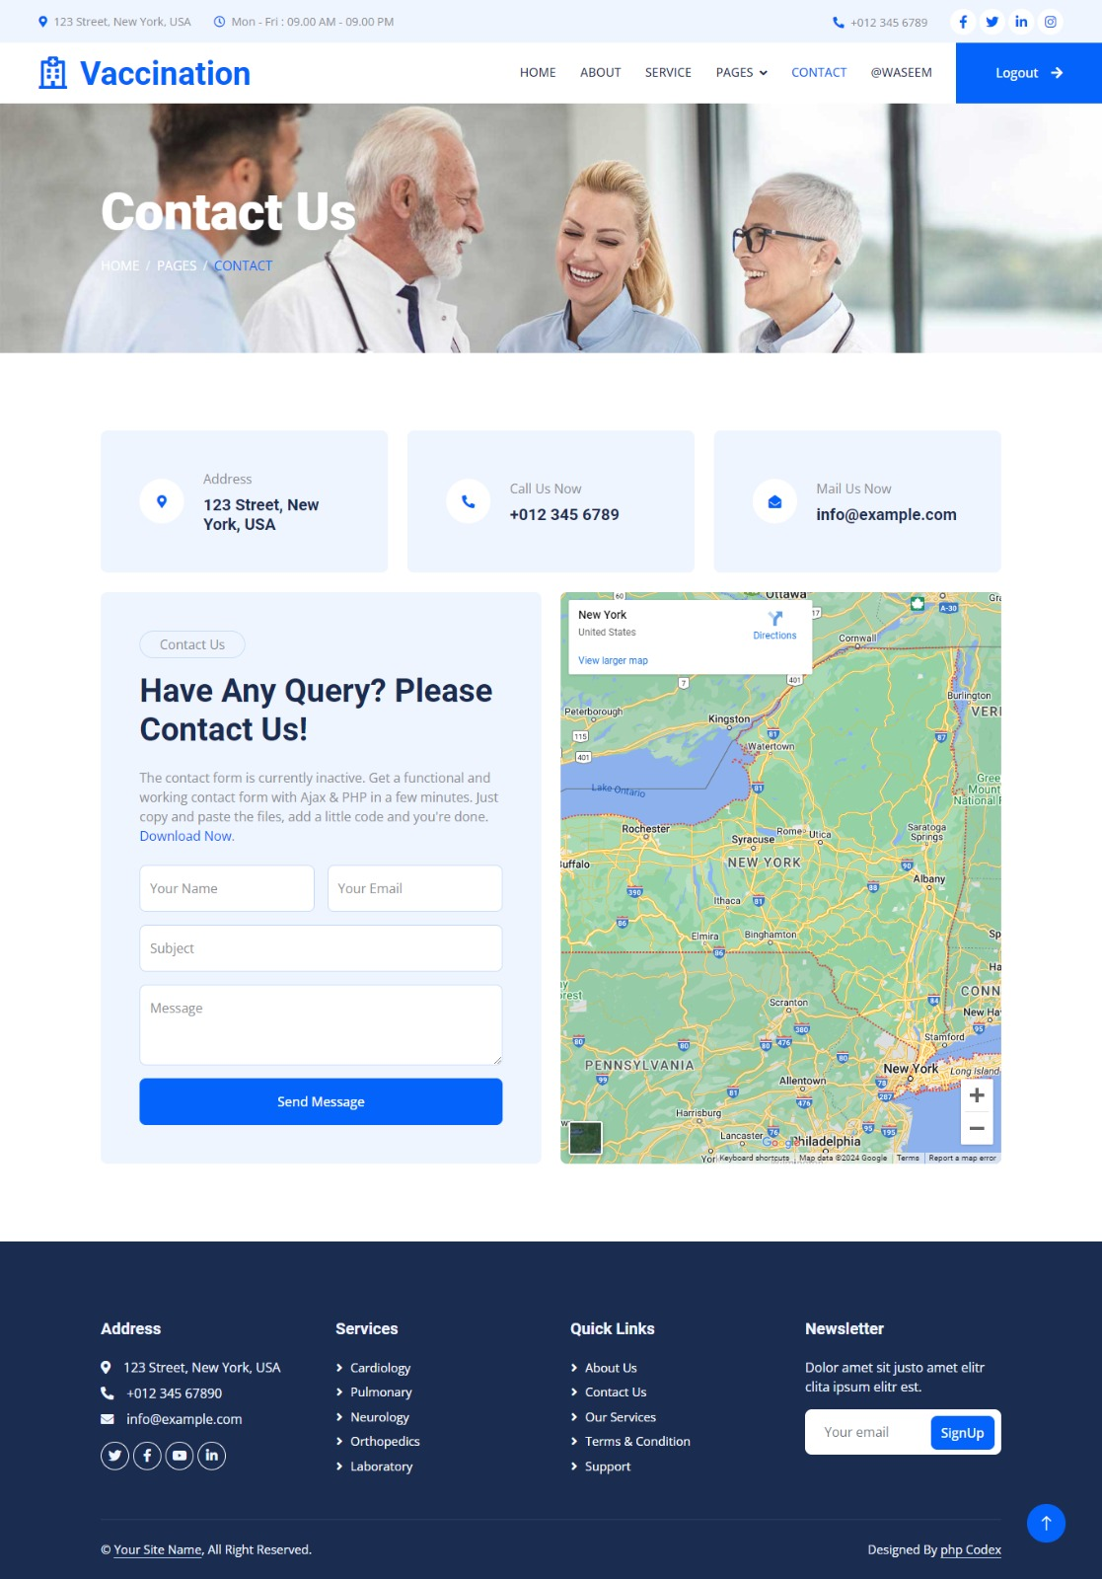Contact

**Coding Screen Shot**

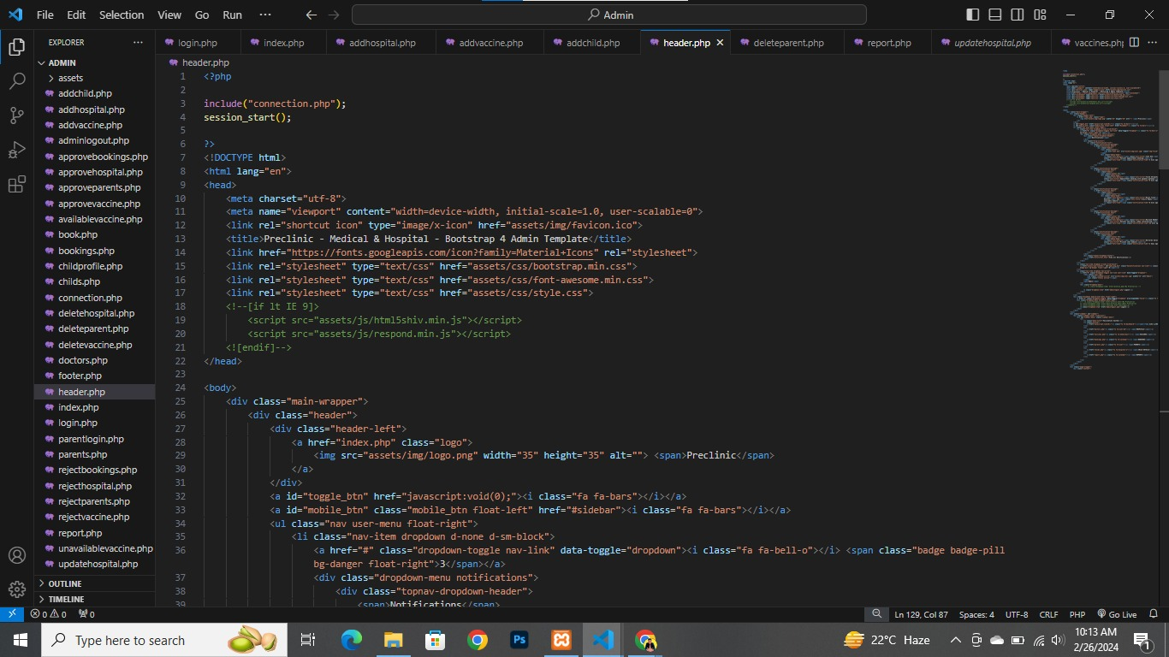Header

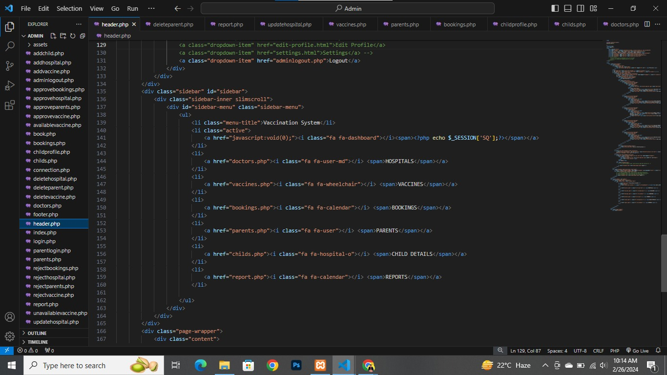

Footer

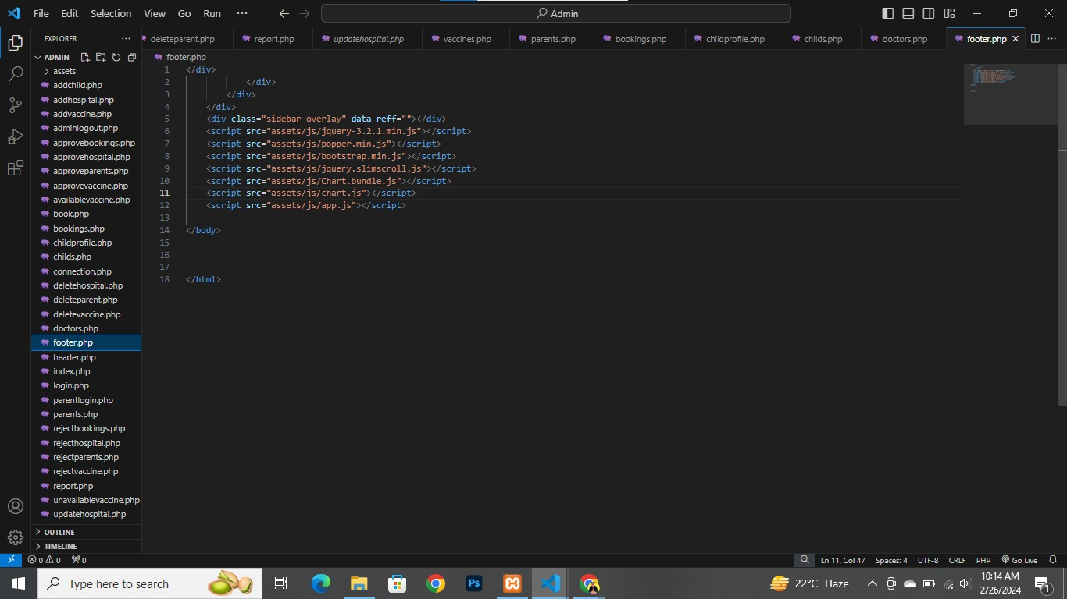

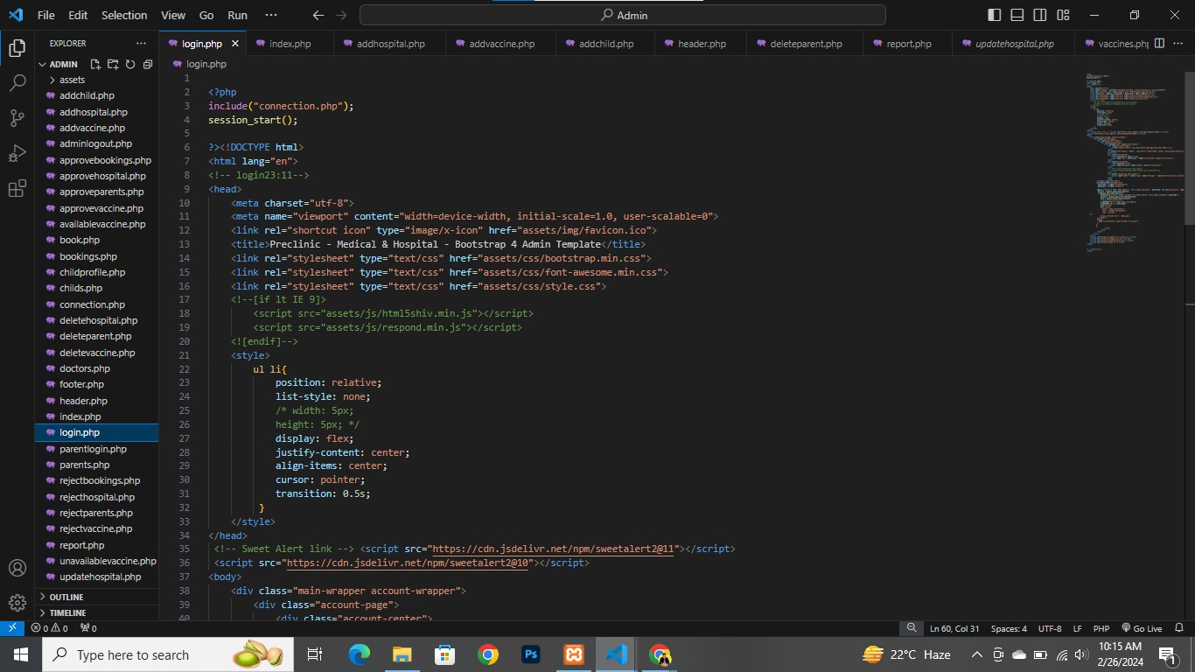Admin Login

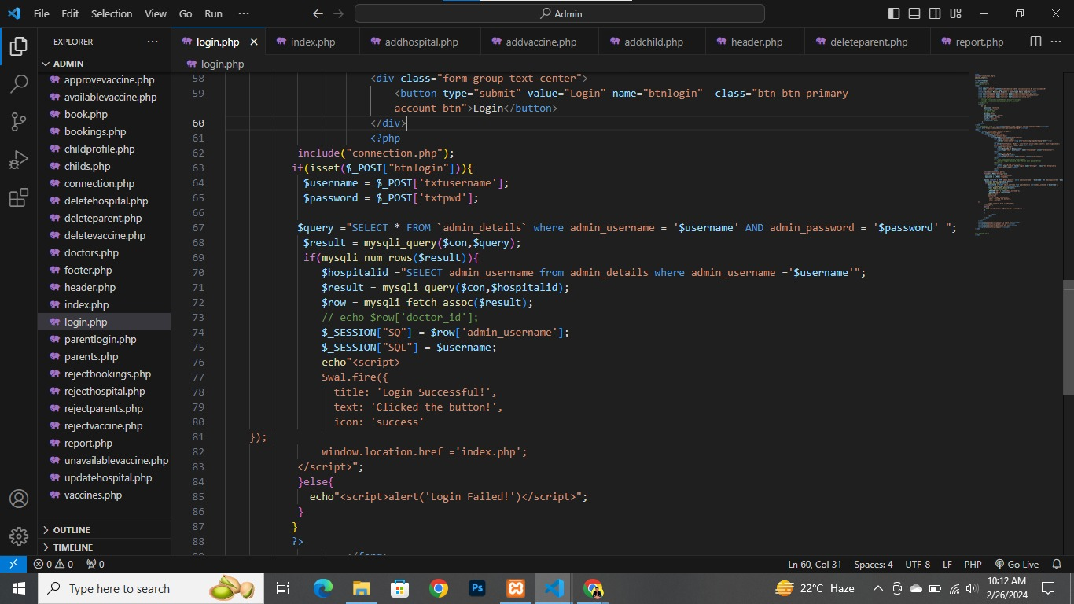

Admin Logout

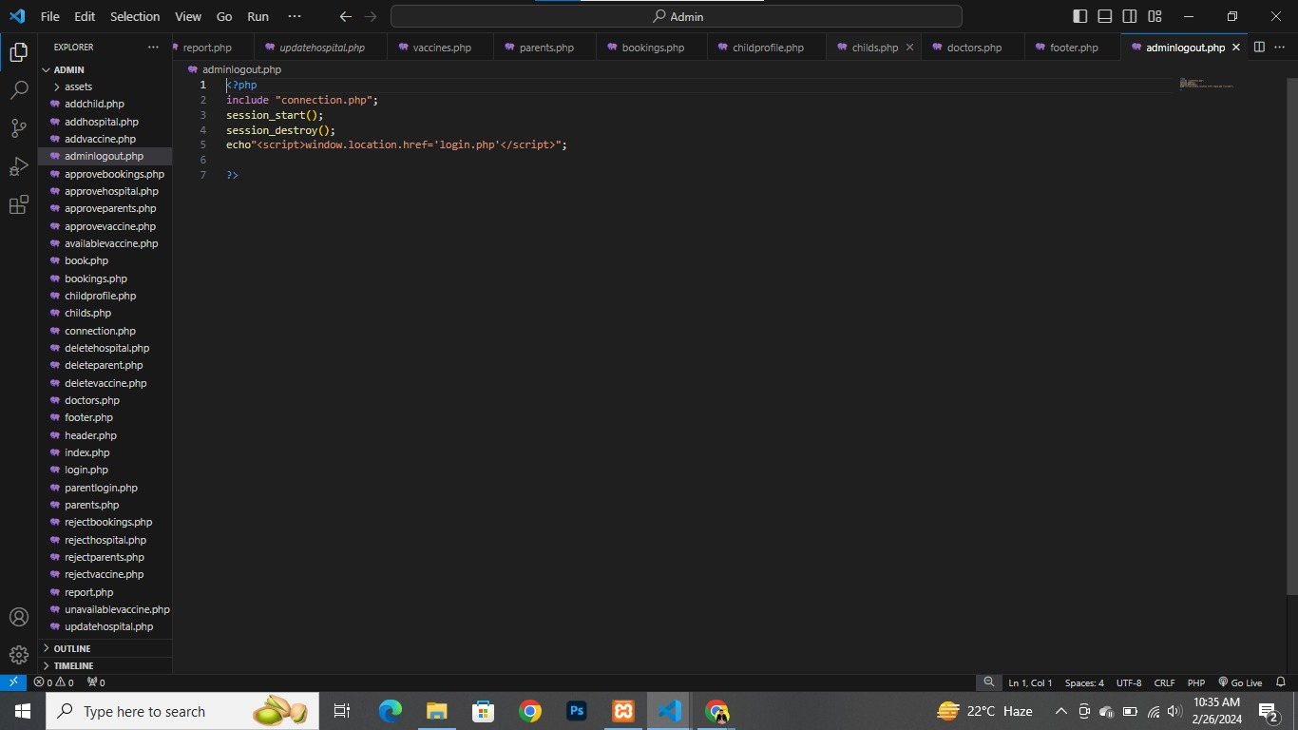

Hospital Login

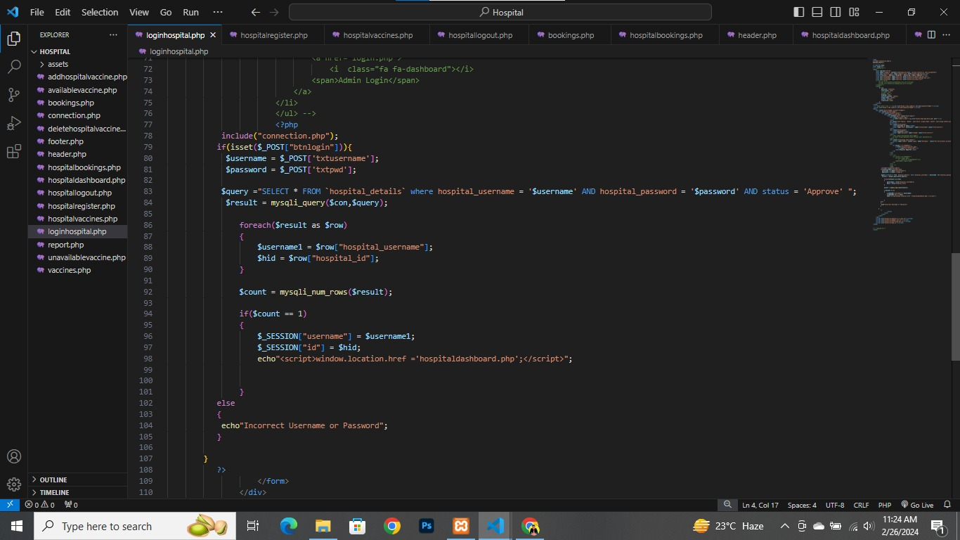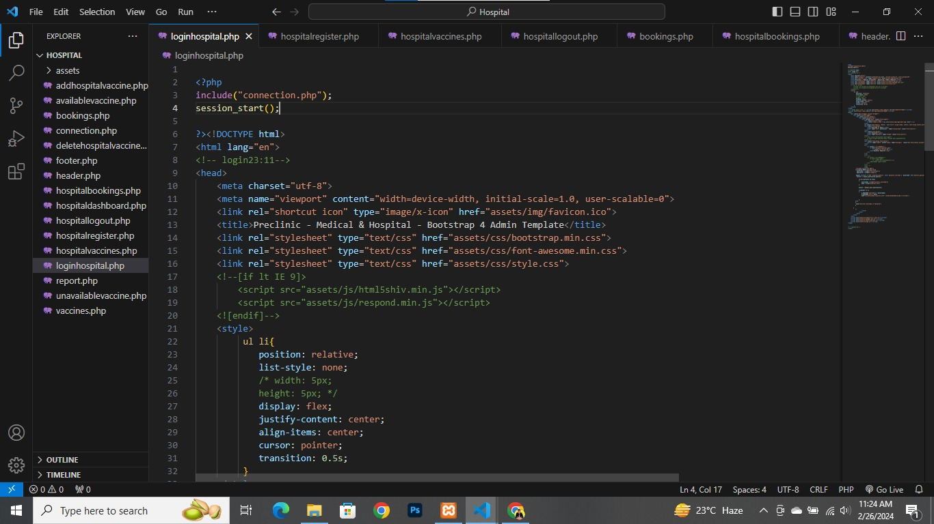

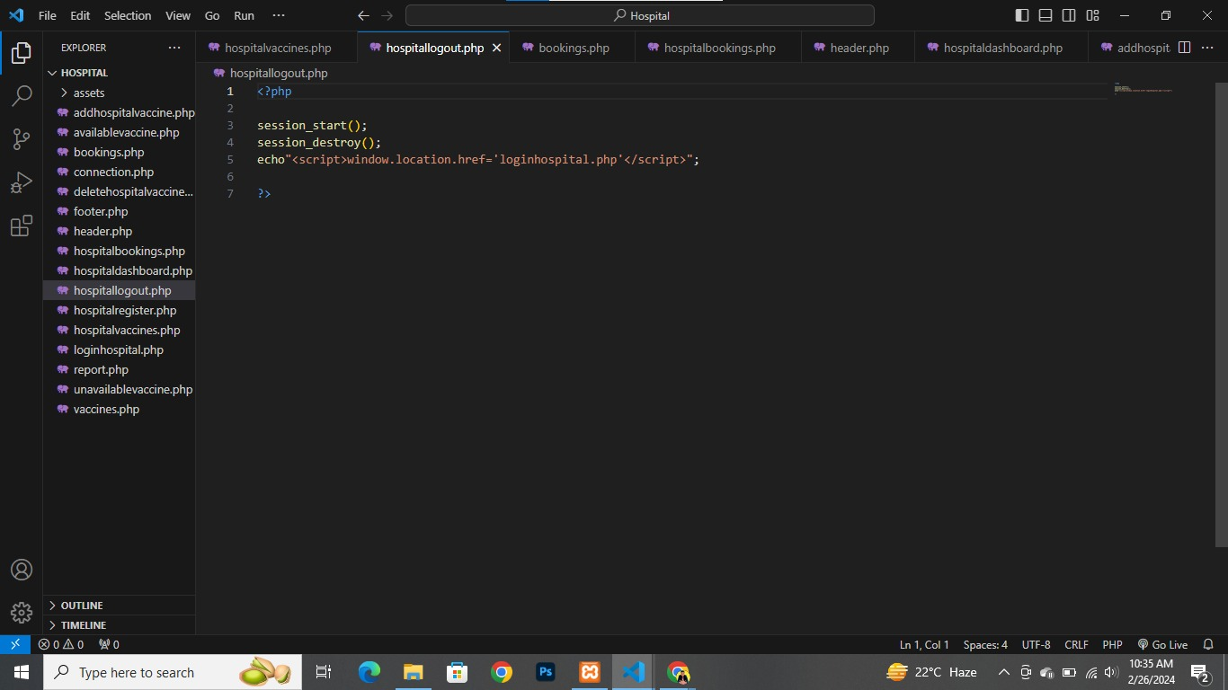Hospital Logout

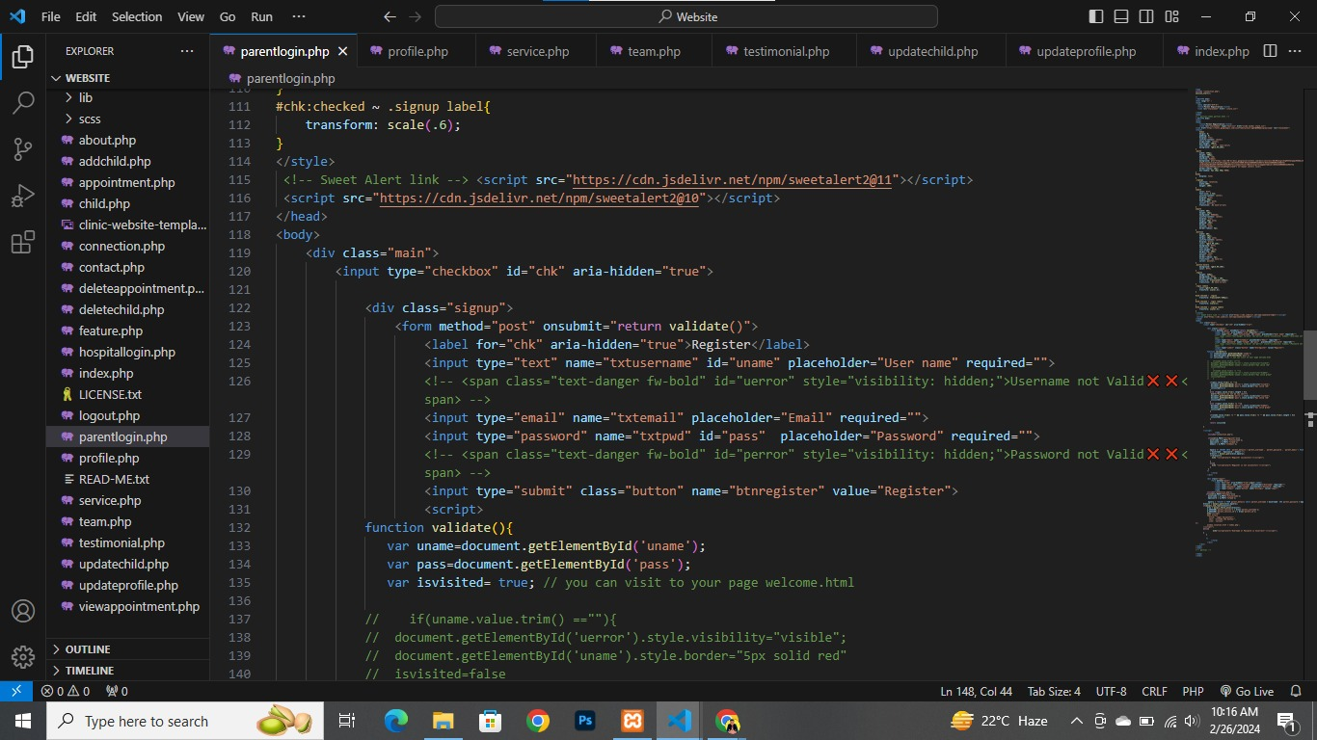Parents Login

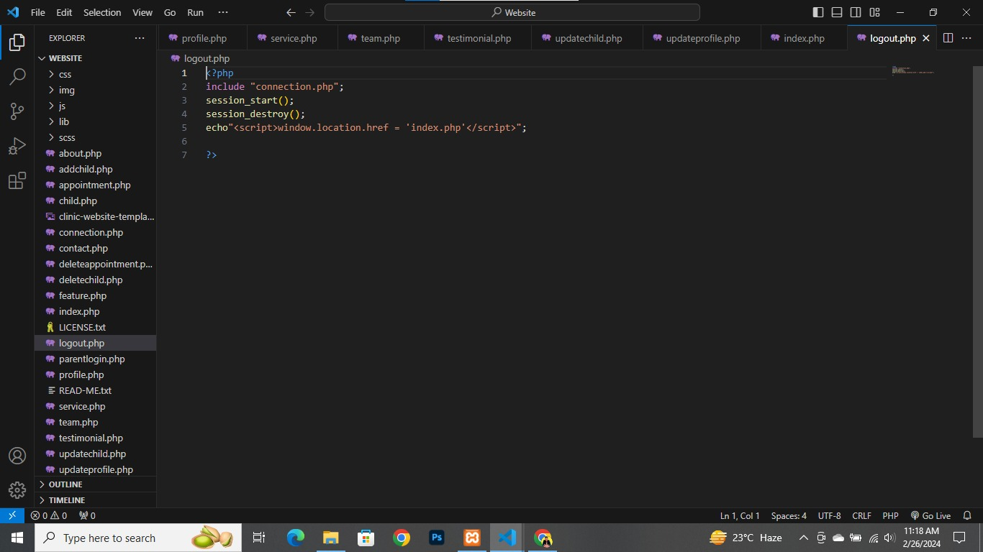Parents Logout

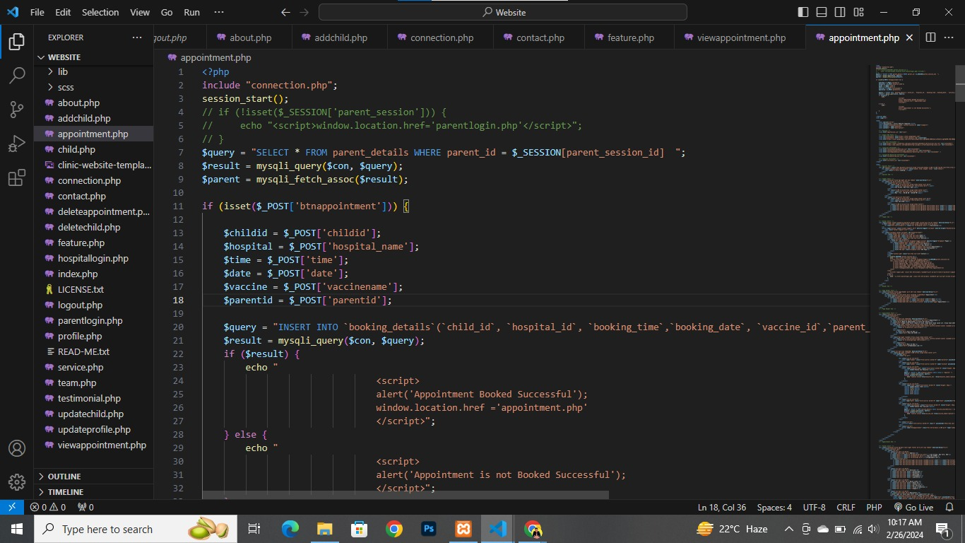Appointment

Booking Details

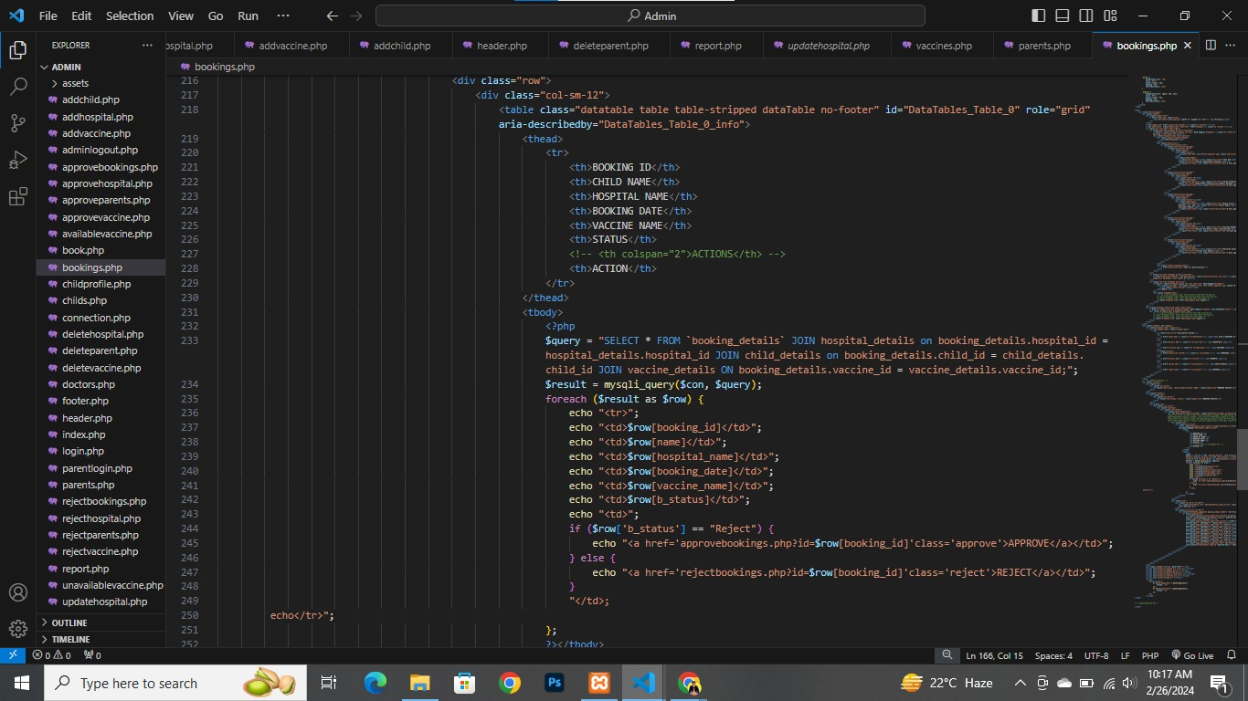

Reports

